**Hypothesis Testing Exercise**

1. A F&B manager wants to determine whether there is any significant difference in the diameter of the cutlet between two units. A randomly selected sample of cutlets was collected from both units and measured? Analyze the data and draw inferences at 5% significance level. Please state the assumptions and tests that you carried out to check validity of the assumptions.

Minitab File : **Cutlets.mtw**

**Answer:**

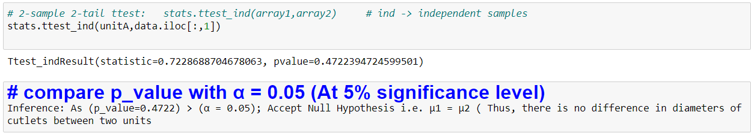

1. A hospital wants to determine whether there is any difference in the average Turn Around Time (TAT) of reports of the laboratories on their preferred list. They collected a random sample and recorded TAT for reports of 4 laboratories. TAT is defined as sample collected to report dispatch.

Analyze the data and dete rmine whether there is any difference in average TAT among the different laboratories at 5% significance level.

Minitab File: **LabTAT.mtw**

**Answer:**

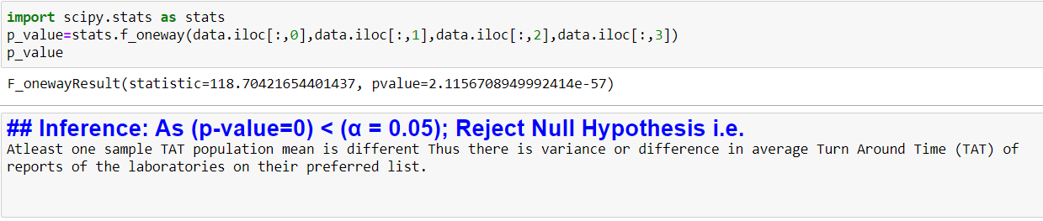

1. Sales of products in four different regions is tabulated for males and females. Find if male-female buyer rations are similar across regions.

|  |  |  |  |  |
| --- | --- | --- | --- | --- |
|  | **East** | **West** | **North** | **South** |
| Males | 50 | 142 | 131 | 70 |
| Females | 550 | 351 | 480 | 350 |

Answer:

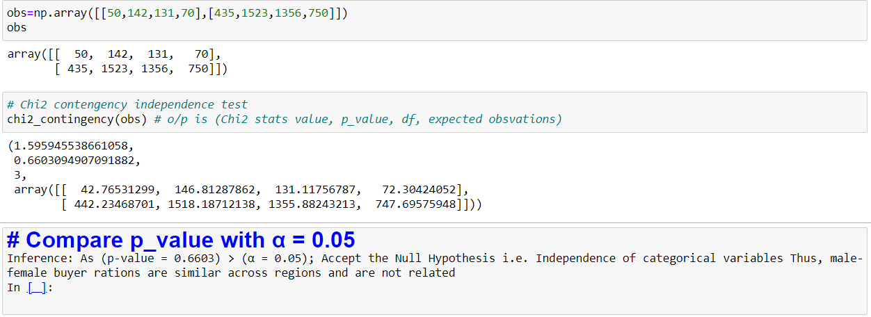

1. TeleCall uses 4 centers around the globe to process customer order forms. They audit a certain % of the customer order forms. Any error in order form renders it defective and has to be reworked before processing. The manager wants to check whether the defective % varies by centre. Please analyze the data at *5%* significance level and help the manager draw appropriate inferences.

Minitab File: **CustomerOrderForm.mtw**

**Answer:**

